**Week 02: In-class R coding practice**

**Group: The Cat Shirts (60% off)**

Jackie Stephens - I found the overall instructions easy to follow along with, and I think the part that caused me most difficulty was understanding how to pull in the arguments for (x, x-intercept, y-intercept, slope) when using the curve function. (I understood the while creating the function of the line intercept slope but got lost when applying it to the animal data)

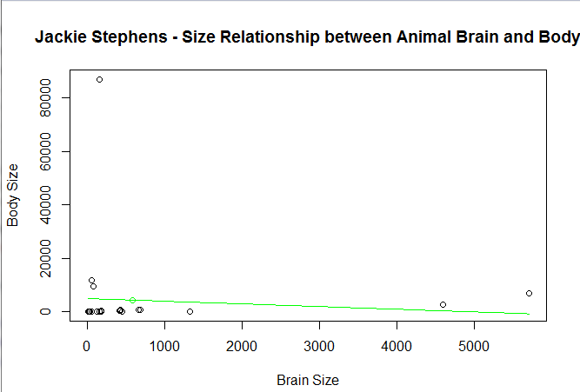

Elyse McCormick

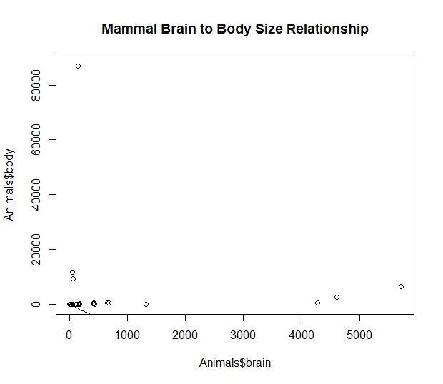

Kato Csanadi-Schwartz

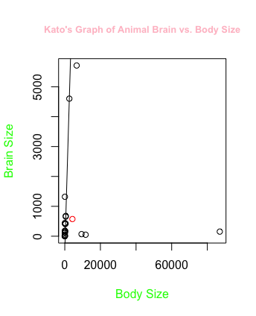

Matthew Jusino

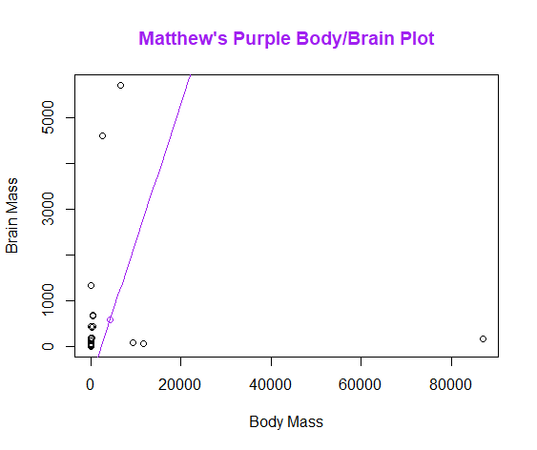

The actual production for this assignment was fairly easy due to the step-by-step instructions. The hardest part was figuring out how to do the customization aspects with titles and labels and colors.

David Murillo

Scatterplot with a line

**Progress**

**Our group completed the exercise, and we were able to talk to each other to**

**Which parts of the exercise were difficult, or too easy ?**

Answer:

The function to estimate the mean “mean()”, standard deviation “sd()”, and make the plot “plot()” were easy to understand.

The function “line_point_slope” was complicated to understand in the beginning, and is still a bit complicated due to not having written the code itself.